**Wep App lab**

**Lab 11 Tasks**

**GET Method:**

<?php

echo "<pre>";

print_r ($_GET);

echo "</pre> "  ;

?>

<h2>HTML Forms</h2>

<form action="form.php" method="GET" >

    <label for="firstname">First name: </label>

    <input type="text" name="firstname"  required>

    <br>

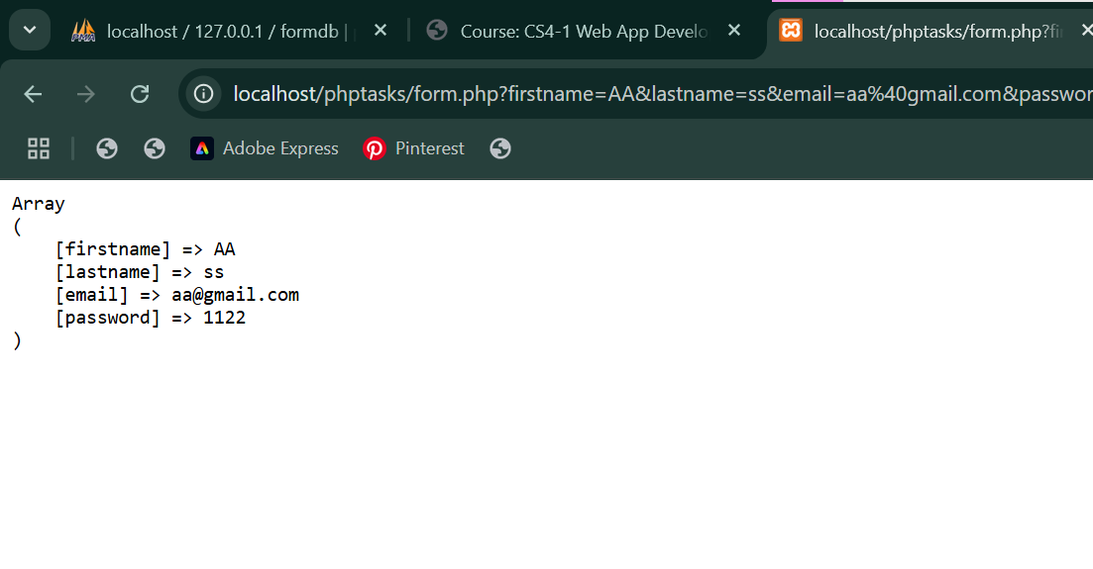

**POST Method:**

<?php

echo "<pre>";

print_r ($_POST);

echo "</pre> "  ;

echo $_POST['firstname'];

echo $_POST['lastname'];

echo $_POST['email'];

echo $_POST['password'];

?>

<h2>HTML Forms</h2>

<form action="form.php" method="POST" >

    <label for="firstname">First name: </label>

    <input type="text" name="firstname"  required>

    <br>

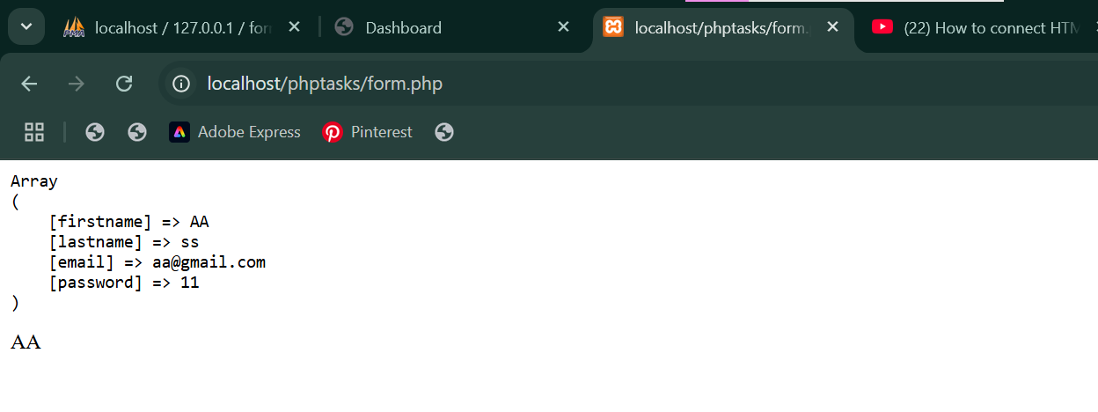

**REQUEST Method**

<?php

echo "<pre>";

print_r ($_REQUEST);

echo "</pre> "  ;

echo $_REQUEST['firstname'];

echo $_REQUEST['lastname'];

echo $_REQUEST['email'];

echo $_REQUEST['password'];

?>

<form action="form.php" method="REQUEST" >

    <label for="firstname">First name: </label>

    <input type="text" name="firstname"  required>

    <br>

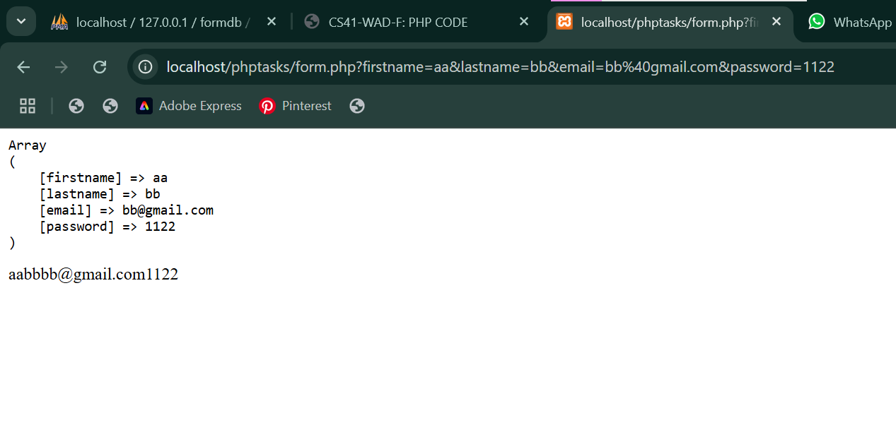

**Difference between GET and POST Method**

**GET Method**



**POST Method**

**SQL Connection**

<?php

$conn = new mysqli("localhost", "root", "", "student", 4307);

if ($conn->connect_error) {

    die("Connection failed: ". $conn->connect_error);

}

$name = $_POST['name'];

$email = $_POST['email'];

$password = $_POST['password'];

$gender = $_POST['gender'];

$message = $_POST['message'];

$sql = "INSERT INTO contact (name, email, password, gender, message)

VALUES ('$name', '$email', '$password', '$gender', '$message')";

if ($conn->query($sql) === TRUE) {

    echo "Inserted successfully";

} else {

    echo "Error: ". $conn->error;

}

$conn->close();

?>

<!DOCTYPE html>

<html>

<body>

<h2>HTML Forms</h2>

<form action="form.php" method="post" >

    <label for="firstname">First name: </label>

    <input type="text" name="firstname"  required>

    <br>

    <label for="lastname">Last name: </label>

    <input type="text" name="lastname"  required>

    <br>

    <label for="email">email: </label>

    <input type="email" name="email"  required>

    <br>

    <label for="password">password: </label>

    <input type="password" name="password"  required>

    <br>

    <input type="submit" value="Login!">

</form>

<p>If you click the "Submit" button, the form-data will be sent to a page called "/action_page.php".</p>

</body>

</html>

